1. What is Medical Tourism?

Executive Summary
Medical tourism (more accurately called Medical Value Travel - MVT) is when a patient travels to another country specifically to receive medical treatment that is either unavailable, unaffordable, delayed, or of lower quality in their home country.
India has become one of the world's leading medical tourism destinations because it combines world-class clinical expertise, internationally accredited hospitals, advanced technology, English-speaking doctors, and significantly lower treatment costs than developed countries. Government initiatives such as the e-Medical Visa, Heal in India, and NABH accreditation have further strengthened India's position.

Why do patients travel?
Patients generally travel for one or more of these reasons:
Reason | Example
Lower cost | Cardiac surgery costing ₹1 crore in the US may cost ₹6–10 lakh in India.
Better quality | Access to experienced specialists and advanced medical technology.
Shorter waiting time | Procedures available within days instead of months.
Treatment unavailable locally | Complex oncology, transplant, cardiac surgery, advanced orthopedics.
Second opinion | Patients seek internationally recognised specialists before major procedures.

India's Competitive Advantage
India is particularly strong in:
- Cardiology & Cardiac Surgery
- Oncology
- Orthopedics & Joint Replacement
- Neurosurgery
- Organ Transplant
- Nephrology & Dialysis
- IVF & Fertility
- Robotic Surgery
Estimated Distribution of India's Medical Tourism Cases by Specialty
Specialty | Estimated Share | Why India Excels
Cardiology & Cardiac Surgery | 22–25% | Internationally renowned cardiac surgeons, advanced cath labs, CABG and valve replacement at significantly lower costs.
Oncology (Cancer Care) | 16–18% | Comprehensive cancer centers, radiation therapy, surgical oncology, hematology, and precision medicine.
Orthopedics & Joint Replacement | 15–17% | High-quality knee, hip, spine, and sports medicine procedures with shorter waiting times.
Neurosurgery | 8–10% | Brain and spine surgery, neuro-oncology, epilepsy surgery, and minimally invasive techniques.
Organ Transplant | 7–9% | Liver, kidney, and bone marrow transplant programs in leading tertiary hospitals (subject to regulatory eligibility).
Nephrology & Dialysis | 7–8% | Long-term dialysis programs and kidney disease management integrated with transplant services.
IVF & Fertility | 10–12% | High success rates, advanced reproductive technologies, and competitive pricing.
Robotic Surgery | 4–6% | Growing use across urology, gynecology, gastrointestinal, and oncology procedures; usually counted within other specialties rather than as a standalone segment.

Unlike countries such as Turkey (cosmetic surgery) or Thailand (wellness and cosmetic procedures), India has built its reputation on complex tertiary and quaternary healthcare.

Market Size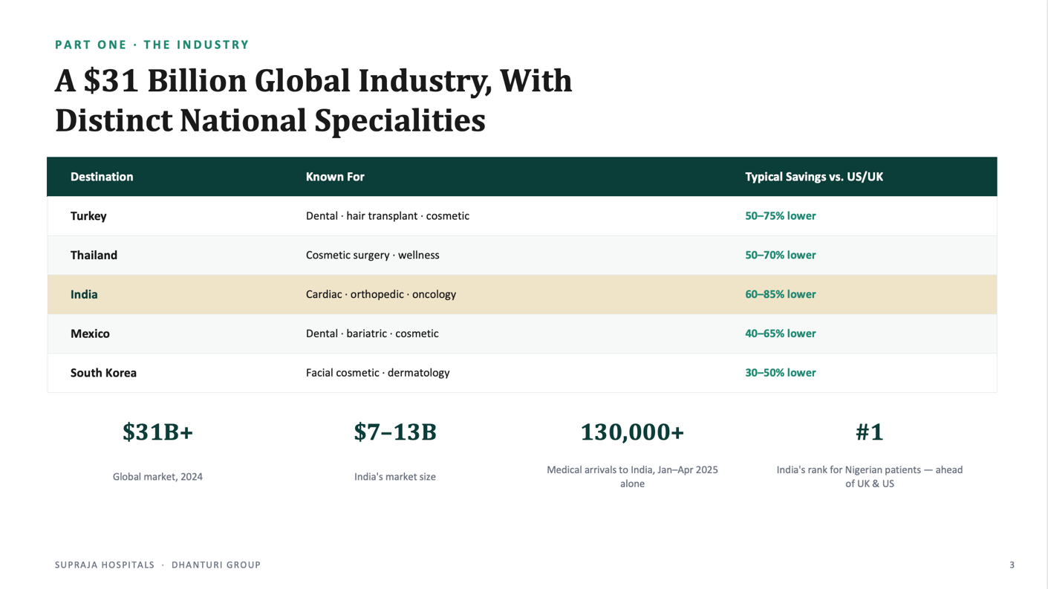

Competitors:
Estimated Share of India's Organized Medical Tourism Market
Hospital Group | Estimated Share | Rationale
Apollo Hospitals | 22–25% | India's largest international brand with dedicated international offices, multiple JCI/NABH hospitals, and strong presence in Africa, Bangladesh, Middle East, and Southeast Asia.
Manipal Hospitals | 14–17% | Largest private hospital network by bed capacity, rapidly expanding international business and transplant services.
Fortis Healthcare | 10–12% | Strong North India presence, international insurance partnerships, and established IPDs.
Max Healthcare | 8–10% | Dominant in NCR with rapidly growing international patient volumes.
Narayana Health | 7–9% | Highly competitive pricing, especially for cardiac surgery, attracting patients from Africa and South Asia.
Others (Medanta, Aster, KIMS, Yashoda, CARE, etc.) | 30–35% | Fragmented among regional and specialty providers.

Estimated Share Within Hyderabad's International Patient Market
For Hyderabad only, the market is concentrated among a few hospital groups.
Hospital | Estimated Share | Strength
Yashoda Hospitals | 25–30% | One of Hyderabad's strongest IPDs with long-standing African and Middle Eastern relationships.
KIMS Hospitals | 18–22% | Large network, multiple specialties, strong Gulf and African inflow.
Apollo Hyderabad | 12–15% | Global brand with established referral channels.
CARE Hospitals | 10–12% | Strong cardiac and transplant reputation.
AIG Hospitals | 8–10% | Gastroenterology, liver sciences, robotic surgery.
Continental Hospitals | 5–8% | Part of IHH Healthcare, growing international business.
Medicover Hospitals | 4–6% | Expanding international outreach, especially in diagnostics and oncology.
Sunshine Hospitals | 3–5% | Strong orthopedics and trauma care.
Others | 5–8% | Smaller multispecialty and specialty hospitals.

African Market Position
If your strategy focuses on Africa, the competitive landscape changes.
Hospital | Africa Presence
Apollo | ★★★★★
Yashoda | ★★★★★
KIMS | ★★★★☆
CARE | ★★★★☆
Narayana | ★★★★☆
Manipal | ★★★★☆
Continental | ★★★☆☆
AIG | ★★★☆☆
Medicover | ★★☆☆☆
Sunshine | ★★☆☆☆

Why this matters for Supraja
Supraja should not compete on price alone.
Instead, the positioning should be:
Affordable international-quality healthcare with personalised hospitality and end-to-end patient management.

2. Supply Chain & Operations
Medical tourism is essentially an international healthcare supply chain, where the hospital manages the patient journey from the moment treatment is considered until the patient safely returns home.

Stage 1 – Market Development
There are two customer acquisition models:

A. Direct Market Development
The hospital actively develops the market.
Activities include:
- Medical camps
- Health awareness programs
- Doctor seminars
- Government meetings
- Embassy engagement
- Corporate partnerships
- Digital marketing
This creates direct trust with patients and institutions.

B. Channel Partner Model
Local facilitators identify patients and connect them with Indian hospitals.
Their responsibilities include:
- Patient counselling
- Translation
- Collecting medical records
- Travel assistance
- Initial consultations
- Documentation
The facilitator earns a commission from the hospital after successful treatment.
This model provides faster market entry but lower margins.

Stage 2 – Patient Qualification
Before the patient travels:
- Medical reports collected
- Specialist review
- Treatment plan prepared
- Cost estimate shared
- Video consultation
- Patient confirms treatment
Only after clinical approval does the hospital issue an invitation letter.

Stage 3 – Visa & Documentation
Hospital issues:
- Medical Invitation Letter
- Cost Estimate
- Doctor Recommendation
- Admission Confirmation
Patient applies for:
- Medical Visa
- Medical Attendant Visa

Stage 4 – Arrival & Logistics
Your notes correctly identify this as one of the biggest differentiators.
The patient should never feel "lost."
Services include:
- Airport pickup
- SIM card assistance
- Currency exchange guidance
- Hotel/guest house check-in
- Local transportation
- Interpreter
- Dedicated relationship manager

Stage 5 – Clinical Care
Hospital manages:
- Registration
- Admission
- Diagnostics
- Surgery
- ICU
- Inpatient stay
- Rehabilitation
Operations team coordinates everything outside clinical care.

Stage 6 – Recovery
Recovery may continue outside the hospital.
This includes:
- Guest house
- Hotel stay
- Diet planning
- Physiotherapy
- Nursing support
- Follow-up appointments

Stage 7 – Return & Follow-up
After discharge:
- Teleconsultations
- Digital prescriptions
- Report sharing
- Local doctor coordination
- Future reviews
This stage generates repeat patients and referrals.

3. Supraja + Dhanturi Hospitality = The X-Factor
This is not just a hotel business.
It creates an integrated recovery ecosystem.
Most hospitals discharge patients once treatment is complete.
International patients still require:
- Accommodation
- Food
- Transportation
- Attendant support
- Emotional comfort
- Safe recovery
Normally hospitals outsource this.
Supraja doesn't have to.

Proposed Integrated Model
Patient lands in Hyderabad

↓

Airport Pickup

↓

Dhanturi Gorup of Hotels

↓

Pre-operative Assessment

↓

Supraja Hospital

↓

Treatment

↓

Recovery

↓

Recovery Stay at the Hotels

↓

Tourism (optional)

↓

Airport Drop

↓

Teleconsultation

Business Benefits

Higher Revenue
Revenue generated from:
- Hospital
- Hotel
- Transport
- Food
- Pharmacy
- Diagnostics
- Rehabilitation

Better Patient Experience
Single organisation manages the entire journey.
Less confusion.
Greater trust.

Better Clinical Outcomes
Patients recover in a controlled environment instead of unsuitable hotels.

Stronger Brand
Market Supraja as:
A Complete International Patient Care Platform
rather than simply a hospital.

4. Basic Setup & Requirements

Clinical
- State hospital registration
- Biomedical waste compliance
- Fire safety
- Pharmacy licence
- Blood bank approvals (if applicable)
- AERB approvals for radiology equipment
- Infection control programme

Accreditation
Priority:
NABH
Future:
JCI (after international volumes justify the investment)

International Patient Department (IPD)
Dedicated team:
- International Business Head
- Marketing Manager
- Case Coordinator
- Visa Officer
- Patient Relationship Executive
- Translator
- Operations Executive
- Billing Executive

Systems
- CRM
- Telemedicine
- WhatsApp Business
- Digital Medical Records
- International Billing
- Foreign Currency Payments

SOPs
Standard operating procedures for:
- Airport pickup
- Admission
- Billing
- Language support
- Discharge
- Follow-up
- Emergency escalation

5. Uganda – The Beginning of an African Strategy
Uganda should not be viewed as the end market.
It should be the pilot corridor.

Why Uganda?
- Existing relationship
- Growing demand for specialised healthcare
- Limited tertiary care capacity
- Patients already travelling abroad
- English-speaking population
- Strong diplomatic relationship with India

Long-Term Vision
Uganda

↓
Somalia

↓

Kenya

↓

Tanzania

↓

Rwanda

↓

South Sudan

↓

Ethiopia

↓

Zambia

↓

Zimbabwe

↓

West Africa
The objective is to replicate the same operating model in each corridor rather than reinventing it.

Expansion Strategy
Year 1
Uganda
Year 2
East Africa
Year 3
Southern Africa
Year 4+
West Africa & Middle East
Each new country builds on the experience, systems, and partnerships established in the previous one.

6. Financial Model
Surgery cost + Services + 10-20% (margin)
The economics work because international patients typically generate significantly higher revenue per case than domestic patients.

Revenue Streams
- Surgery
- Consultation
- Diagnostics
- ICU
- Pharmacy
- Rehabilitation
- Hotel
- Airport transfer
- Visa assistance
- Teleconsultation

Cost Structure
Fixed:
- IPD salaries
- Marketing
- Accreditation
- Technology
- Office
Variable:
- Facilitator commission
- Transport
- Translation
- Patient support
- Hotel services

Margin Improvement
Early stage:
Facilitator model
↓
Higher commission
↓
Lower margins
Later stage:
Government referrals
↓
Direct institutional patients
↓
Minimal commission
↓
Higher profitability

This transition is one of the biggest value drivers in the strategy.
Medical Tourism Financial Model (Realistic Base Case)

Assumptions
- We start with Uganda as our first market.
- We don't spend heavily on international marketing initially.
- We primarily acquire patients through facilitators and our Uganda relationship.
- The hospital already exists, so this investment is only for building the medical tourism division.

Initial Investment
Investment | Cost (₹ Lakhs)
International Patient Department (IPD) Setup | 20
NABH Preparation | 35
Website, Branding & Marketing | 20
Staff Recruitment & Training | 15
CRM & Digital Systems | 10
Working Capital | 25
Total Investment | ₹1.25 Crore
Message to stakeholders:
"This is not an investment to build a new hospital. It is an investment to build an international patient business."

Patient Growth Plan
Year | Patients per Month | Patients per Year
Year 1 | 5 | 60
Year 2 | 12 | 144
Year 3 | 20 | 240

Why is this realistic?
- Year 1: We are building relationships and trust.
- Year 2: Facilitator network grows, NABH accreditation is in place, and referrals increase.
- Year 3: Government partnerships and patient referrals start generating consistent business.

Average Revenue Per Patient
Each international patient contributes revenue across multiple services.
Revenue Source | Average Revenue
Hospital Treatment | ₹4.80 Lakhs
Diagnostics & Pharmacy | ₹20,000
Hotel & Recovery Stay | ₹25,000
Transport & Other Services | ₹17,000
Total Revenue per Patient | ₹5.42 Lakhs
Message to stakeholders:
"We are not earning only from surgery. Every international patient also generates revenue through diagnostics, pharmacy, accommodation, transport, and follow-up care."

Annual Revenue
Year | Patients | Revenue
Year 1 | 60 | ₹3.25 Crore
Year 2 | 144 | ₹7.80 Crore
Year 3 | 240 | ₹13.00 Crore

Operating Expenses
Year | Operating Cost
Year 1 | ₹2.80 Crore
Year 2 | ₹6.40 Crore
Year 3 | ₹10.00 Crore
These include:
- Staff salaries
- Marketing
- Facilitator commissions
- Patient logistics
- International travel
- Administration

Profit (EBITDA)
Year | EBITDA
Year 1 | ₹45 Lakhs
Year 2 | ₹1.40 Crore
Year 3 | ₹3.00 Crore

Break-even
We expect to recover the initial investment in approximately 2.5 to 3 years.
This is a realistic timeline for a new international patient program.

7. Keys to Success
Medical tourism is not won by the cheapest hospital.
It is won by the hospital that builds the most trusted and seamless patient journey.
The critical success factors are:
- Clinical Excellence – Strong outcomes, experienced doctors, internationally accepted standards.
- Trust & Transparency – Clear package pricing, ethical communication, no hidden costs.
- End-to-End Patient Experience – Airport pickup, accommodation, translators, logistics, follow-up.
- Strategic Market Development – Build both facilitator relationships and institutional partnerships, gradually shifting toward direct referrals.
- Operational Discipline – Dedicated IPD, standard operating procedures, fast response times, multilingual support, and continuous patient engagement.
- Integrated Hospitality – Use Dhanturi Hotels to provide a recovery environment that enhances both patient satisfaction and overall value.
- Scalable Corridor Strategy – Prove the model in Uganda first, document the playbook, then replicate it across East Africa before expanding to other regions.

One message for stakeholders
The opportunity is not simply to attract foreign patients. The objective is to build an integrated international healthcare platform where Supraja Hospitals delivers the clinical care and Dhanturi Group delivers the recovery and hospitality experience, creating a differentiated model that can be scaled corridor by corridor across Africa.

